**Q Can I combine different event types together? Or do all need to be handled separately?**

1 - Retirement

2 - Voluntary Resignation

3 - Involuntary Resignation (Health problems, family matters etc.)

4 - Job Termination, Employee is Fired

Below graph shown states that employees are resigning voluntary more in comparisons to other event types and all event types are in different proportions in the employees.

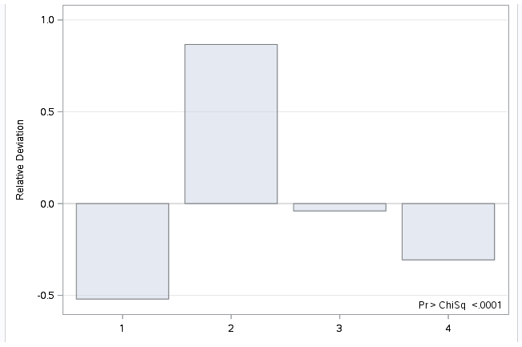

**Proc Freq results shows that they are not same for all event types.**

To confirm the above point, we have plotted frequency of all event types of employees in the organization. Explain in terms of figures

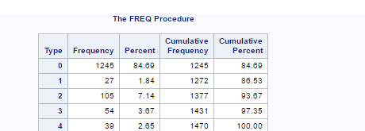

To confirm the above frequency plot and to cross validate the number of employees leaving in an organization, our team has plotted “Frequency Plot” between event type and turnover. Plot shows that 105 out of 225 belongs to Voluntary resignation which is major reason of attrition in organization & has become a concern for the company.

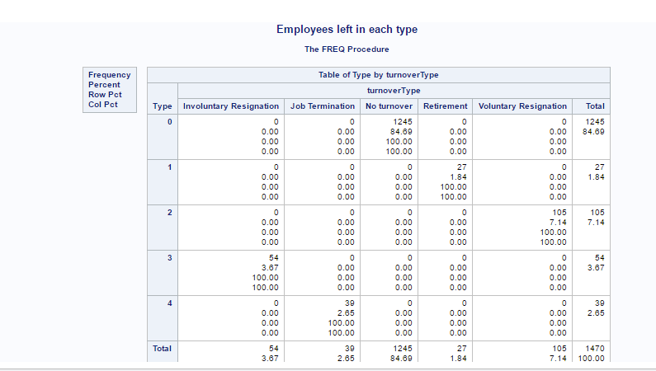

To check whether hazards for all event types are linearly related with each other, our team has tested each event type individually and created one variable called event which has censored the other types and then we combined all event types to check whether they are linearly realed with each other using Log-log Survival plot(LLS) which is used for Weibull using PROC LIFETEST DATA, which also helps in understanding the shape of the hazard function.”Diff = all” is used to compare all the strata of turnover.

By looking at the p-values of Wilcoxon test shows that all other event types are significant and different from each other except Involuntary Resignation and Job termination because these two event types are similar.

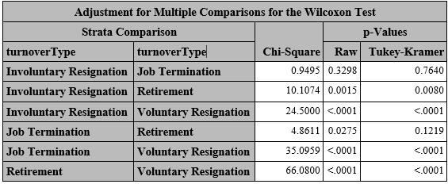

Below graph of Survival estimates also prove the above fact that employees who are falling under the event of Involuntary resignation and Job Termination are linearly proportional and there seems a possibility that these events can be handled together.

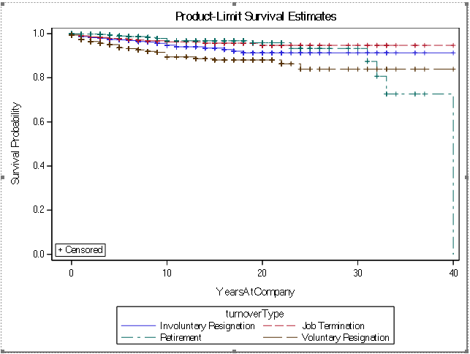

To add to the above point, our team has plotted LLS graphs for all 4 event types -Involuntary, Job termination, Retirement and Voluntary Resignation and graph seems that $ω$ values are same for Involuntary and Terminated employees. But to check the possibility of using both event types together, our team has decided to apply PHREG model for each event type and combine event type

